The Title Should Be in Title Case (See Below), Single Spaced, Times New Roman, Bold 14-point, Left-justified, with a Maximum of 300 Characters or 75 Words

First Author¹, Second Author^{2*} and Patricia Tolan^{1,3} (Times New Roman 12-pt left-justified) Each name should have a superscript Arabic number to reference the author’s affiliation. A superscript asterisk after the affiliation number indicates the corresponding author (e-mail address only). Use single line spacing. Leave one blank line between the title and author list, and one blank line after the authors’ names before the list of affiliations. Avoid abbreviations for departments and institutions, but do use abbreviations when listing states/provinces/etc. . Do NOT use complete mailing addresses for affiliation listings.

¹ Affiliation of the first author, Department/Institution, City, State/Province, Country. (12pt)
² Affiliation of the second author, Department/Institution, City, State/Province, Country. (12pt)
³ Department of History, University of Illinois – Urbana-Champaign, Urbana, IL, United States.
* Corresponding author: SAuthor@prydonian.edu

The submission should be a condensed version of your presentation and include all significant findings. Write the text so that readers who are not specialists can appreciate the purpose of the study and understand the procedures and conclusions. The text, entirely written in English, should include a brief introduction and motivation of the study, including experimental procedures, main results, and conclusions. It is not necessary to divide the text into sub-sections, except for the References section.
Capitalize all major words in your title as shown in the example above (nouns, pronouns, verbs, adjectives, adverbs, and some conjunctions). Use lowercase for articles: the, a, and an; for the following conjunctions: and, but, for, or, and nor; for the part of a proper name that would be lowercased in the text, such as de or von; and for the second part of a species name, such as fulvescens in Acipenser fulvescens, even if it is the last word in a title or subtitle.
Your submission must be a Microsoft Word file in .doc or .docx formats. Use a 12-point Times New Roman typeface and single spacing between lines. Use italics for taxonomic terms. Avoid individualized formatting and special typefaces. Document size should be 8.5 x 11 inches (21.59 x 27.94 cm), with margins of 1.0 inch (25.4 mm) top and bottom and 0.75 inch (19.1 mm) left and right. The body of the text (i.e., excluding title, authors, affiliations, references, and figure captions) should be full-justified and between 100-1200 words. Papers with word counts outside of this range will be rejected. Do not indent the first paragraph, but indent all subsequent paragraphs.
A maximum of four figures may appear in your submission. Figures are NOT required for regular submissions, but submissions applying for a Meeting Award are required to have two figures. Include figure labels and scale markers on all figures. Captions should be placed below all figures and tables. Figures should appear after the body text and before the references. Artwork and tables must be electronically inserted into the document. Color figures may be used and will be reproduced in any electronic proceedings distributed. If printed, paper copies will be in grayscale, so ensure that color coding used for legends is distinguishable in grayscale. Line art must be created either in drawing software or scanned into a suitable format for importing into the document. Check that the line widths and font sizes allow the figure to be clear at its final size. Consider accessibility when designing your figure(s), so that your images can be easily understood by color-blind and visually impaired readers.
References are included at the end of the text, with the appropriate reference styles for journal articles [1, 2], books [3], conference proceedings [4], and websites [5]. Indicate references within the text with Arabic numbers in square brackets, preferably at the end of the sentence, before the period. For references with three or more authors, use the first-named author followed by “et al.”. Acknowledgements, statements regarding of the division of work, or disclaimers should be included in the last reference, which is cited at the end of the last sentence of the text.
All submissions are reviewed by the Program Committee according to the following criteria: (a) relevance to a specific symposium, (b) scientific content, quality and innovative proposals, (c) clarity of the text, and (d) compliance with the format. Papers not meeting these criteria will not be accepted. All submissions for society and meeting awards, scholarships, and prizes must meet these requirements. After the closing date for paper submissions, neither paper content nor author lists will be accessible for corrections.
All accepted papers must be presented by a meeting registrant. If the registrant cannot attend due to unforeseen circumstances, an alternate presenter should be arranged by the submitter [6].

Fig. 1. Times New Roman, 12pt., left-justified. Provide a short description of the figure, including labels and scale markers as appropriate.

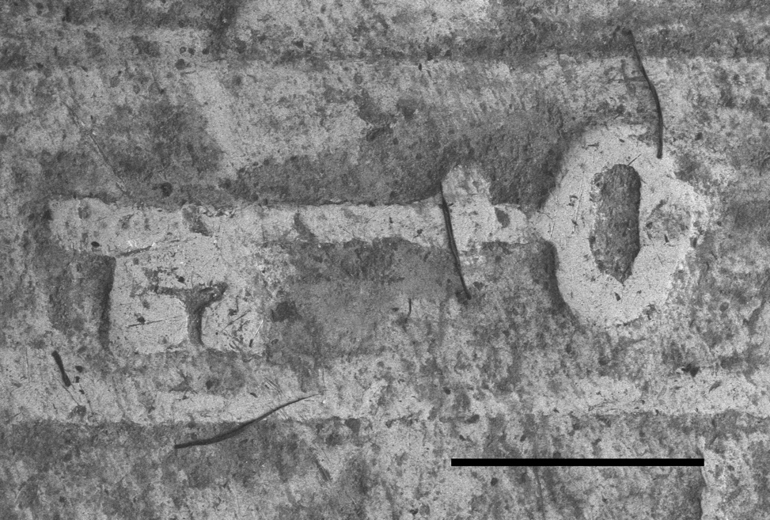

Fig. 2. Times New Roman, 12pt., left-justified. Provide a short description of the figure, including labels and scale markers as appropriate. Scale bar = 1mm.

References: (Times New Roman, 12-pt, left-justified, 2000 characters maximum)

1. F Author and S Author, Journal volume (year), p. 1. https://doi.org/10.1038/s41592-021-01156-w
2. F Author et al., Journal [Online] volume, Article number (year), http://www.website.com (accessed Month Day, Year).
3. F Author in “Introduction to abstract writing”, ed. T Editor, (Publisher, City) p.1.
4. F Author and S Author, Conference Proceedings (year), p. 1.
5. Title of website, http://www.examplewebsite.com (accessed Month Day, Year).
6. The authors acknowledge funding from the Prydonian Academy, X-File Department. Dr. E Gilbert is thanked for her many useful discussions and contributions to this work.

